PRATHIBHA S

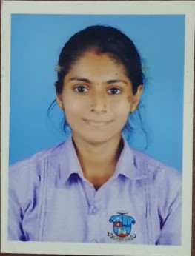

**Hash Infotech | Internship**

* Pursued internship for 1 month in Full Stack Development where I got a opportunity to learn skills needed for website development.
* After Early Completion of my internship, I got opportunity to be a part of client project.

 [***prathibhas887@gmail.com***](mailto:prathibhas887@gmail.com)**Kandev house Padil post Alape village, Mangalore-575007**

## 9742042130

As a recent graduate, I am seeking a role which allows me to continue learning and perfecting my skills as I provide high-quality work, and encourages me to flourish as an employee.

# EXPERIENCE:



# EDUCATION QUALIFICATION: PROJECT:

* BCA

St Agnes Autonomous College |Mangalore, India (2021-24)

* PUC

Padua College of Commerce and Management |Mangalore, India (2019-21)

* SSLC

Navachethana English Medium High School| Mangalore, India (2019)

**Crime Investigator**

* This is a web-based project Where users can report crimes, submit complaints and access information about wanted criminals.



**ACHIEVEMENTS:**

* Secured 2nd Place in web designing at info vision national level IT fest held at AIMIT Mangalore.
* Participated in web designing and coding competition held at St Joseph Engineering College
* Participated in web designing competition held at Canara College
* Participated in coding competition held at St Aloysius College
* Participated in coding competition held at St Agnes Post Graduate College.



# KEY SKILLS: TECHNICAL SKILLS:

* Team Management
* Good Leadership quality
* Determined & Disciplined
* Willingness to learn & Team worker
* Ability to work under pressure
* Quick Learner
* HTML, CSS
* JAVASCRIPT
* PHP
* MYSQL
* C
* JAVA

# DECLARATION:

I, Prathibha S hereby declare that above information is correct to the best of my knowledge and belief.